***NOLLE***

***Damien***

***L3 – Informatique***

**ADO – Devoir 3 :**

|  |  |
| --- | --- |
| ***Note :*** | ***Observation :*** |
| ***/20*** |  |

Exercice 1)

Q1)

On sait que la mémoire cache contient 8 blocs, 1 bloc équivaut à 32 bits.

Déplacement = puissance de la taille d’un bloc = 32 bits = 32 / 8 = 4 octets = 22 = 2 bits

* Fonction correspondance directe :

Index = Puissance du nombre de blocs en mémoire cache = 8 blocs = 23 = 3 bits

Nb blocs mémoire cache = TC / NOBP

8 = TC/4

8 * 4 = 32 octets

32/4 = 8 = 23

Etiquette = taille adresse – taille déplacement – taille index

= 15 – 2 – 3 = 10 bits

* Fonction correspondance associative par ensemble de 4 :

Index = puissance (de 2, pour tous) du nombre d’ensemble dans la mémoire cache = NEC = NBC / NBPE = 8 / 4 = 2 ensembles dans la mémoire cache = 21 = 1 bits.

Etiquette = taille adresse – taille déplacement – taille index = 15 – 2 – 1 = 12 bits

Q2)

0x2000 = 0010 0000 0000 0000

0100000000 000 00

0001 0000 0000 = 0x100 (Etiquette)

000 = 0x0 (index)

0x2010 = 0010 0000 0001 0000

0100000000 100 00

100 = 4 = 0x4 (Index)

01 0000 0000 = 0x100 (Etiquette)

0x2020 = 0010 0000 0010 0000

0100000001 000 00

Index = 000 = 0 = 0x0

Etiquette = 01 0000 0001 = 0x101

Calcul du taux de succès :

1/6

1*8/6*8 = 8/48

Q3 :

0x2000 = 0010 0000 0000 0000

010000000000 0 00

Etiquette = 0100 0000 0000 = 0x400

Index = 0

0x2010 = 0010 0000 0001 0000

010000000010 0 00

Etiquette = 0100 0000 0010 = 0x402

Index = 0

0x2020 = 0010 0000 0010 0000

010000000100 0 00

Etiquette = 0100 0000 0100 = 0x404

Index = 0

Calcul du taux de succès :

3/6

3 * 8/6 * 8 = 24/48

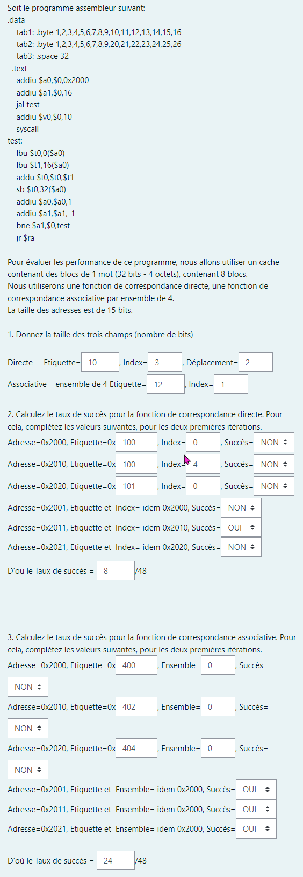

Exercice 2)

Q1 :

|  |  |  |  |  |  |  |  |  |  |  |  |  |  |  |  |  |  |  |
| --- | --- | --- | --- | --- | --- | --- | --- | --- | --- | --- | --- | --- | --- | --- | --- | --- | --- | --- |
| Instruction/cycle | 1 | 2 | 3 | 4 | 5 | 6 | 7 | 8 | 9 | 10 | 11 | 12 | 13 | 14 | 15 | 16 | 17 | 18 |
| lbu $t0,0($a0) | LI | DI | EX | M | ER |  |  |  |  |  |  |  |  |  |  |  |  |  |
| lbu $t1,16($a0) |  | LI | DI | EX | M | ER |  |  |  |  |  |  |  |  |  |  |  |  |
| addu $t0,$t0,$t1 |  |  | LI | DI | DI | DI | EX | M | ER |  |  |  |  |  |  |  |  |  |
| sb $t0,32($a0) |  |  |  | LI | LI | LI | DI | DI | DI | EX | M | ER |  |  |  |  |  |  |
| addiu $a0,$a0,1 |  |  |  |  |  |  | LI | LI | LI | DI | EX | M | ER |  |  |  |  |  |
| addiu $a1,$a1,-1 |  |  |  |  |  |  |  |  |  | LI | DI | EX | M | ER |  |  |  |  |
| bne $a1,$0,test |  |  |  |  |  |  |  |  |  |  | LI | DI | DI | DI | EX | M | ER |  |
| lbu $t0,0($a0) |  |  |  |  |  |  |  |  |  |  |  | LI | LI | LI | DI | EX | M | ER |

5 + (n – 1) (nombre d’étages - 1) = 5 + (8 – 1) = 12

3ème instruction : dépendance $t1, $t0

4ème instruction : dépendance $t0

5ème instruction : dépendance $a1

6ème instruction : dépendance : $a0, $t0

On a donc une dépendance sur $t1, $t0, $a0 et $a1.

XXLDDDEMW

XXXLLLDDDEMW

XXXXXXLLLDEMW

XXXXXXXXXLDEMW

XXXXXXXXXXLDDDEMW

XXXXXXXXXXXLLLDEMW

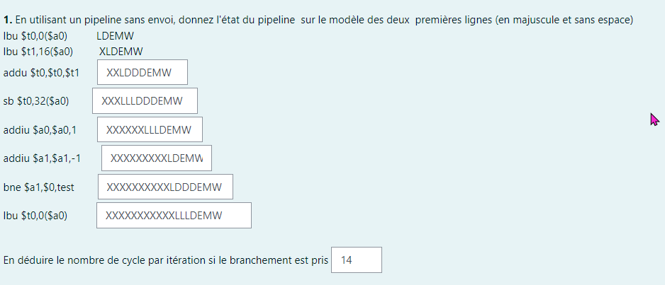

Q2 :

|  |  |  |  |  |  |  |  |  |  |  |  |  |  |  |  |  |  |  |
| --- | --- | --- | --- | --- | --- | --- | --- | --- | --- | --- | --- | --- | --- | --- | --- | --- | --- | --- |
| Instruction/cycle | 1 | 2 | 3 | 4 | 5 | 6 | 7 | 8 | 9 | 10 | 11 | 12 | 13 | 14 | 15 | 16 | 17 | 18 |
| lbu $t0,0($a0) | LI | DI | EX | M | ER |  |  |  |  |  |  |  |  |  |  |  |  |  |
| lbu $t1,16($a0) |  | LI | DI | EX | M | ER |  |  |  |  |  |  |  |  |  |  |  |  |
| addu $t0,$t0,$t1 |  |  | LI | DI | DI | DI | EX | M | ER |  |  |  |  |  |  |  |  |  |
| sb $t0,32($a0) |  |  |  | LI | LI | LI | DI | DI | DI | EX | M | ER |  |  |  |  |  |  |
| addiu $a0,$a0,1 |  |  |  |  |  |  | LI | LI | LI | DI | EX | M | ER |  |  |  |  |  |
| addiu $a1,$a1,-1 |  |  |  |  |  |  |  |  |  | LI | DI | EX | M | ER |  |  |  |  |
| bne $a1,$0,test |  |  |  |  |  |  |  |  |  |  | LI | DI | DI | DI | EX | M | ER |  |
| lbu $t0,0($a0) |  |  |  |  |  |  |  |  |  |  |  | LI | LI | LI | DI | EX | M | ER |

|  |  |  |  |  |  |  |  |  |  |  |  |  |  |  |  |  |  |  |
| --- | --- | --- | --- | --- | --- | --- | --- | --- | --- | --- | --- | --- | --- | --- | --- | --- | --- | --- |
| Instruction/cycle | 1 | 2 | 3 | 4 | 5 | 6 | 7 | 8 | 9 | 10 | 11 | 12 | 13 | 14 | 15 | 16 | 17 | 18 |
| lbu $t0,0($a0) | LI | DI | EX | M | ER |  |  |  |  |  |  |  |  |  |  |  |  |  |
| lbu $t1,16($a0) |  | LI | DI | EX | M | ER |  |  |  |  |  |  |  |  |  |  |  |  |
| addu $t0,$t0,$t1 |  |  | LI | DI | EX | EX | M | ER |  |  |  |  |  |  |  |  |  |  |
| sb $t0,32($a0) |  |  |  | LI | DI | DI | EX | M | ER |  |  |  |  |  |  |  |  |  |
| addiu $a0,$a0,1 |  |  |  |  | LI | LI | DI | EX | M | ER |  |  |  |  |  |  |  |  |
| addiu $a1,$a1,-1 |  |  |  |  |  |  | LI | DI | EX | M | ER |  |  |  |  |  |  |  |
| bne $a1,$0,test |  |  |  |  |  |  |  | LI | DI | EX | M | ER |  |  |  |  |  |  |
| lbu $t0,0($a0) |  |  |  |  |  |  |  |  | LI | DI | EX | M | ER |  |  |  |  |  |

XXLDEEMW

XXXLDDEMW

XXXXLLDEMW

XXXXXXLDEMW

XXXXXXXLDEMW

XXXXXXXXLDEMW

|  |  |  |  |  |  |  |  |  |  |  |  |  |  |  |  |  |  |  |
| --- | --- | --- | --- | --- | --- | --- | --- | --- | --- | --- | --- | --- | --- | --- | --- | --- | --- | --- |
| Instruction/cycle | 1 | 2 | 3 | 4 | 5 | 6 | 7 | 8 | 9 | 10 | 11 | 12 | 13 | 14 | 15 | 16 | 17 | 18 |
| lbu $t0,0($a0) | LI | DI | EX | M | ER |  |  |  |  |  |  |  |  |  |  |  |  |  |
| lbu $t1,16($a0) |  | LI | DI | EX | M | ER |  |  |  |  |  |  |  |  |  |  |  |  |
| addu $t0,$t0,$t1 |  |  | LI | DI | EX | EX | M | ER |  |  |  |  |  |  |  |  |  |  |
| sb $t0,32($a0) |  |  |  | LI | DI | DI | EX | M | ER |  |  |  |  |  |  |  |  |  |
| addiu $a0,$a0,1 |  |  |  |  | LI | LI | DI | EX | M | ER |  |  |  |  |  |  |  |  |
| addiu $a1,$a1,-1 |  |  |  |  |  |  | LI | DI | EX | M | ER |  |  |  |  |  |  |  |
| bne $a1,$0,test |  |  |  |  |  |  |  | LI | DI | EX | M | ER |  |  |  |  |  |  |
| lbu $t0,0($a0) |  |  |  |  |  |  |  |  | LI | DI | EX | M | ER |  |  |  |  |  |

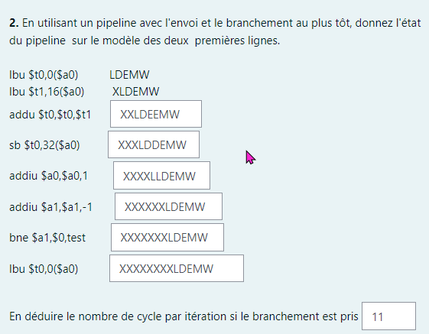

Q3 :

|  |  |  |  |  |  |  |  |  |  |  |  |  |  |  |  |  |  |  |
| --- | --- | --- | --- | --- | --- | --- | --- | --- | --- | --- | --- | --- | --- | --- | --- | --- | --- | --- |
| Instruction/cycle | 1 | 2 | 3 | 4 | 5 | 6 | 7 | 8 | 9 | 10 | 11 | 12 | 13 | 14 | 15 | 16 | 17 | 18 |
| lbu $t0,0($a0) | LI | DI | EX | M | ER |  |  |  |  |  |  |  |  |  |  |  |  |  |
| lbu $t1,16($a0) |  | LI | DI | EX | M | ER |  |  |  |  |  |  |  |  |  |  |  |  |
| addu $t0,$t0,$t1 |  |  | LI | DI | EX | EX | M | ER |  |  |  |  |  |  |  |  |  |  |
| addiu $a1,$a1,-1 |  |  |  | LI | DI | EX | M | ER |  |  |  |  |  |  |  |  |  |  |
| sb $t0,32($a0) |  |  |  |  | LI | DI | EX | M | ER |  |  |  |  |  |  |  |  |  |
| addiu $a0,$a0,1 |  |  |  |  |  | LI | DI | EX | M | ER |  |  |  |  |  |  |  |  |
| bne $a1,$0,test |  |  |  |  |  |  | LI | DI | EX | M | ER |  |  |  |  |  |  |  |
| lbu $t0,0($a0) |  |  |  |  |  |  |  | LI | DI | EX | M | ER |  |  |  |  |  |  |

